**Sub-marine Seafood Subs**

**Java Project**

**Patterns:**

* **Decorator -> Toppings/Ingredients for sandwich**
* **Observer -> The stock of ingredients for sandwiches and meals**
* **Command -> Signals when order is ready**
* **Singleton-factory -> Store is the class, different instances for each sandwich**
* **Strategy -> Take care of the transactions ( credit, cash, paypal)**
* **Adapter -> Special sandwich used into regular sandwich**

**Feel Free to add more**

**Paradigms: Imperative Languages, OO Language Paradiagm (SmallTalk, Java, CLOS, C++)**

**Work Delegation:**

* **Troy ->**
  + **UI Design**
  + **Sandwich Graphics**
  + **Powerpoint Documentation/Organization**
  + **Strategy Pattern**
* **Kevin ->** 
  + **Decorator Pattern**
  + **Singleton-Factory Collab**
* **Kenneth ->** 
  + **Singleton-Factory Collab**
  + **Paradigm Description**
* **Jemma ->** 
  + **Observer Pattern**
  + **UML Creator**
* **Albert ->**
  + **Adapter Pattern**
  + **Sequence Diagrams**
* **Chas ->**
  + **Command Pattern**
  + **Use Case Tables**

**UI Mockups:**

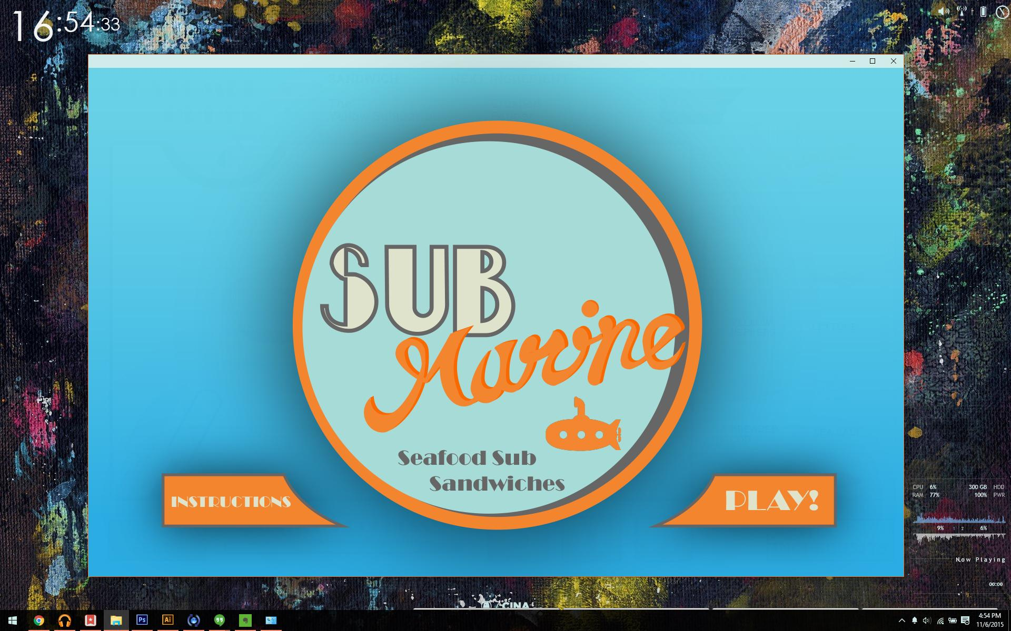

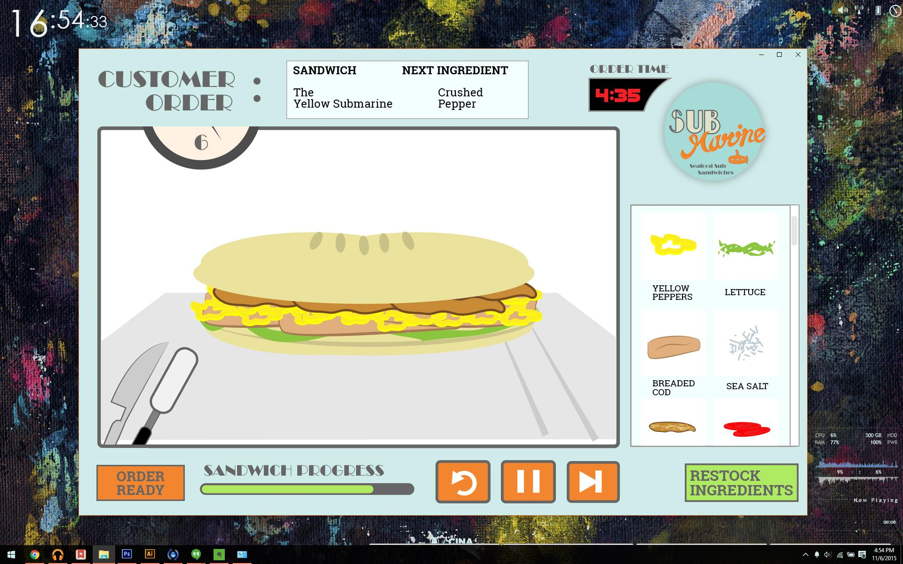

**UML Diagrams:**

**(Placeholder)**

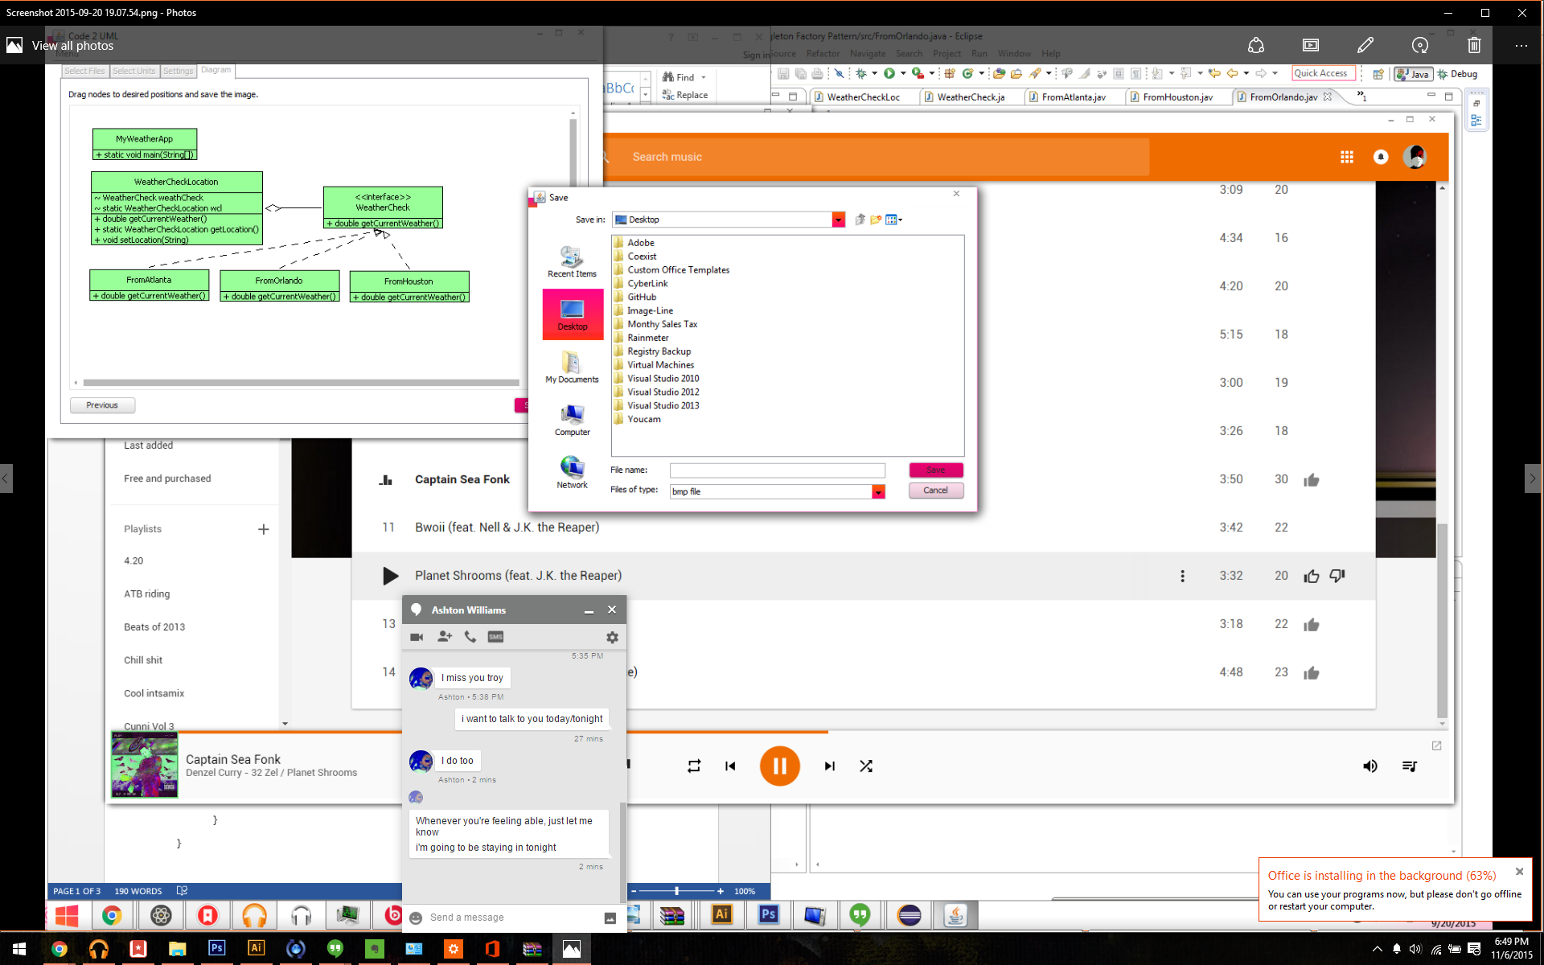

**Sequence Execution Diagram:**

**(Placeholder)**

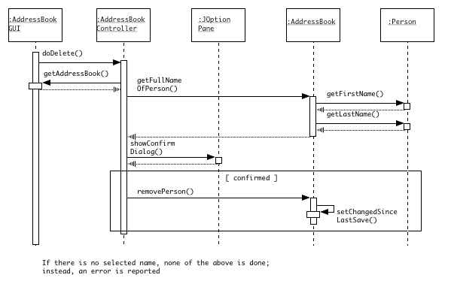

**Paradigm Followed:**

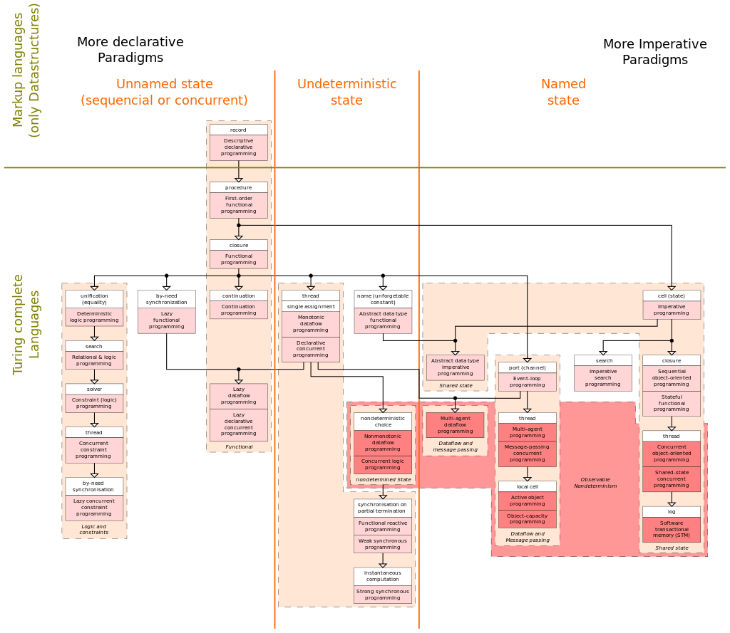**(Placeholder)**

**Use Cases:**

**(Placeholder)**

**\\\**